**CHAPTER 1:**

**INTRODUCTION**

Many scientific and ocean-based operations, such as wave energy generators, ocean wave monitoring systems, ocean wave abnormalities detection systems, coastal area monitoring systems, weather forecasting systems, tsunami forecasting systems, ship navigation systems, ocean water harvesting systems, and so on, require information on ocean wave amplitude and wavelength. As a result, information on the wavelength and amplitude of ocean waves can be used to accurately manage these activities [1], [2].

In practice, measuring the significant wave amplitude and wavelength in real time is difficult due to the high cost of collecting essential data. However, because meteorological data, ocean photographs, and artificially manufactured water wave images are accessible or can be acquired more cheaply than wave data, they can be used to obtain important information about the waves. For estimating wave height and length, two methods have been devised. Numerical techniques and Machine Learning (ML) methods are the two types.

**Numerical Wave Models** [3] The concept of a wind–wave energy spectrum is based on the idea that wave energy grows and decays in response to changes in the wind field. The spectral energy balance equation is used in numerical approaches to estimate significant wave height. It can also be expressed as follows:

(𝜎,𝜃,𝑡)𝜕𝑡=δ𝑖𝑛+δ𝑛𝑙+δ𝑑𝑠,

Where 𝐄 (𝜎, 𝜃, 𝑡) is a two-dimensional wave spectrum that is affected by frequency and propagation direction. δ is the net source function, which is dependent on external wave-making elements such local wind and current, δnl non-linear energy transfer by wave–wave interactions, and ds dissipation. The resonant interaction between waves and turbulent pressure patterns in the air, as well as the feedback between growing waves and generated turbulent pressure patterns, are commonly depicted as the energy input term in a numerical model. The dissipation term ds are expressed in the wave model as a function of wave steepness and is dependent on the energy in the waves as well as the wave steepness. The amplitude is calculated using this equation; however the theoretical method necessitates a great deal of knowledge. The energy balance equation calculates the rate of change in sea state induced by adiabatic processes like advection, as well as physical source functions like wind-generated ocean waves, white-capping dissipation, and nonlinear four-wave interactions. The physics source functions are defined, as well as the numerical scheme for solving the energy balance problem (with special emphasis on the so-called Garden-Sprinkler Effect). When comparing projections with buoy data from different years, the improvement in ocean wave predicting skill may be shown. The formula approach, also known as the theoretical method, is used to forecast ocean waves. This path to ocean wave forecasting will take a long time to complete. About 50 years of research has been done there was a significant but slow development about this concept.

**Machine Learning(ML) methods** [4]Machine learning is a type of data analysis that automates the creation of analytical models. It's a subset of artificial intelligence predicated on the premise that machines can learn from data, recognize patterns, and make decisions with little or no human participation [5].Soft computing algorithms are used to achieve this. Machine learning techniques such as the Artificial Neural Network (ANN), Support Vector Machine (SVM), Bayesian Network, and Fuzzy Inference System are widely used in regression and classification. ANN techniques used neural network topologies to learn the complicated link between inputs and outputs from a vast amount of data.

For our project, we used a soft-computing approach and an ANN-based machine learning algorithm. ANNs are biologically inspired computer algorithms that are supposed to mimic the way the human brain analyses data. ANNs learn (or are trained) by finding patterns and correlations in data and learning (or being trained) via experience rather than programming. An ANN is made up of hundreds of single units, also known as artificial neurons or processing elements (PE), which are coupled by coefficients (weights) and organized in layers to form the neural structure. The strength of neural computations is derived from the interconnection of neurons in a network. Weighted inputs, a transfer function, and one output are all included in each PE. The transfer functions of a neural network's neurons, the learning rule, and the design itself all influence the network's behavior. In this sense, a neural network is a parameterized system because the weights are the adjustable parameters. The activation of the neuron is determined by the weighted total of the inputs. The activation signal is transferred through a transfer function, which results in a single neuron output. The network's non-linearity is introduced by the transfer function. The inter-unit connections are optimized during training until the prediction error is minimized and the network reaches the desired degree of accuracy. New input information can be added to the network after it has been trained and tested to predict the output. We designed a LSTM based ANN that leverages the dataset, which is a collection of photos recorded for various purposes, using the tensor, OpenCV, etc. flow libraries. The OpenCV libraries assist in training the neural network using the available data set according to the appropriate algorithm that outlines the issue statement. After the neural network has been trained, it will be able to deliver output with the highest level of accuracy. We build a machine learning model and image processing to captures photos, processes them, and produces accurate results [6], [7].

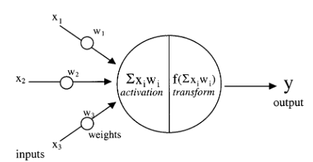

Fig 1.1 Artificial neural networks ANN processing units [6]

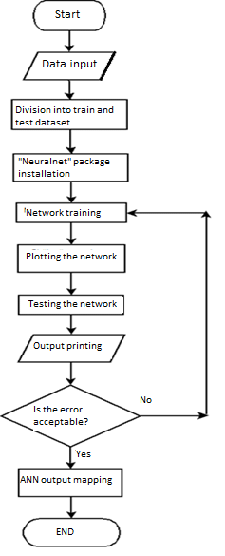

Fig 1.2 Artificial neural network process flow chart [8]

In this paper, we develop a wavelength estimate models based on ocean wave images generated by an ocean wave generator and acquired at a low cost with an optical camera. First, we use an ANN-based classification model to predict significant wave height level and wavelength from a single raw ocean wave image. To find the best ANN design for processing ocean wave photos, we looked at a few well-known ANN architectures, including as VGG Net, Inception.v3, Res Net, and Dense Net, which performed well in a variety of image classification problems.

To begin, we manually estimate relevant wavelength levels from a single ocean wave photograph. The algorithm was constructed using the manually created wave model as a guide. After the neural network has been trained, it will be able to deliver output with the highest level of accuracy. We can use these to build a machine learning model that captures real-time photos of ocean waves, processes them, and outputs an accurate wavelength and altitude of the waves. Video of the ocean waves was captured and converted into photos to create a dataset for testing and training. Further down in the paper, there are more detailed explanations.

**CHAPTER 2:**

**LITERATURE REVIEW**

As per J. Walker, Machine learning is the study of computer algorithms that can learn and develop on their own with experience and data. It is considered to be a component of artificial intelligence. Because machine learning models learn the structure of the problem from the data without any prior theoretical assumptions about the data generation process, it is chosen over traditional theoretical assumptions or mathematical approaches. This could make the model selection process more efficient and less prone to subjective biases. Furthermore, it has been suggested that understanding the structure from data has the added benefit of allowing for the discovery of the unexpected. Second, especially in the case of prediction applications, machine learning models often achieve superior goodness-of-fit than their theory-driven equivalents [5].

According to D. Smilkov *et al.*, TensorFlow.js is a JavaScript library for creating and running machine learning algorithms. Models written in TensorFlow.js run in a web browser and in the Node.js environment. The library is part of the Tensor Flow environment, which provides a collection of Python APIs that may be used to migrate models across the Python and JavaScript ecosystems. TensorFlow.js has given a new set of JavaScript developers the ability to design and deploy machine learning models, as well as enabling new types of on-device computation. Tensor Flow allows you to train and test your ANN using the algorithm. Furthermore, the test and training data were provided to improve the output accuracy [7].

As per G. Xie and W. Lu, OpenCV is one of the most comprehensive software libraries for computer vision. OpenCV is a free and open-source computer vision library. It is made up of a set of C / C ++ functions and classes that provide a variety of standard image processing and computer vision methods that may be used to accomplish sophisticated image processing and develop real-time applications systems. [9].

In the study which was proposed by S. Agatonovic-Kustrin M. Šapina M and R. Beresford, ANNs are computer programs inspired by biology and aimed to mimic the way the human brain processes information. ANNs learn (or are trained) by identifying patterns and correlations in data. They do not learn (or are trained) by programming. An ANN is made up of hundreds of single units, also known as artificial neurons or processing elements (PE), which are coupled by coefficients (weights) and organized in layers to form the neural structure. The strength of neural computations is derived from the interconnection of neurons in a network. Weighted inputs, a transfer function, and one output are all included in each PE. The transfer functions of a neural network's neurons, the learning rule, and the design itself all influence the network's behavior. The weights are the movable parameters; therefore a neural network is a parameterized system in that sense. The activation of the neuron is determined by the weighted total of the inputs. The activation signal is transferred through a transfer function, which results in a single neuron output. The network's non-linearity is introduced by the transfer function. The inter-unit connections are optimized during training until the prediction error is minimized and the network reaches the desired degree of accuracy. New input information can be added to the network after it has been trained and tested to predict the output [6] [8].

According to D. Smilkov *et al.,* We can design an ANN that leverages the dataset, which is a collection of photos recorded for various purposes, using the tensor flow libraries. Tensor flow uses the available data set to train the neural network according to the required algorithm that specifies the problem statement. After the neural network has been trained, it will be able to deliver output with the highest level of accuracy. We may use these to build a machine learning model that captures photos, processes them, and produces accurate results [7].

As per R. Phadnis, J. Mishra, and S. Bendale Frequent objects tend to follow specific patterns in terms of time and geographic movement. Analyzing these patterns can assist us in keeping a better watch of the object's pattern, allowing us to forecast and predict the outcome. To model the neural network, Google's Tensor Flow, a relatively new toolkit, was used. Multiple objects in real-time video streams are detected using the Tensor Flow Object Detection API. We may utilize the reference [7] to construct an algorithm that will recognize trends and warn the user if an abnormality is discovered [10].

Different types of ocean waves forecasting that are obtained through the study are as follows:

P. A. E. M. Janssen proposed that in Theoretical approach, the fundamental law for wave prediction, particularly the energy balance equation, is discussed in the context of ocean wave forecasting. The energy balance equation calculates the rate of change in sea state due to adiabatic processes like advection, as well as physical source functions like wind-generated ocean waves, white-capping dissipation, and nonlinear four-wave interactions. The numerical technique for solving the energy balance equation is based on the formulation of physics source functions (with special emphasis on the so-called Garden-Sprinkler Effect Comparison of forecast results with buoy observations over different years demonstrates improvement in ocean wave forecasting skill. For the forecasting of ocean waves, this is a formula method or theoretical method. This path to ocean wave forecasting development could take many years; roughly 50 years of research has been done, and there has been significant but sluggish progress on this topic [3].

X. Ma proposed that in Phase-resolved approach using ANN and LWP: A vessel's phase-resolved wave prediction is critical for anticipating predictable motion as well as supporting decision-making. To achieve phase-resolved wave prediction, both linear and nonlinear physical-based wave models are necessary. The Fast Fourier Transform (FFT) technology is used to create these physical-based models. Nonlinear wave models, such as high order spectrum models, are capable of modeling nonlinear waves, although they still have no stationary issues. Wave motions must be linear and stationary in order to use the FFT approach. As a result of machine learning's ability to tackle nonlinear dynamic problems, a machine learning method is used to forecast phase-resolved waves. As a result, an ANN-WP (ANN-based Wave Prediction) model is proposed. In model training optimization, verification, and comparison investigations, experimental wave data sets are used. The ANN-WP model's prediction accuracy is verified, and the input–output method for training optimization of the ANN-WP model is investigated. Using nonlinear experimental wave data, a comparison between the ANN-WP and linear wave prediction (LWP) models is shown. A basic examination of the ANN-WP model's capacity to anticipate severe waves is also offered. The ANN-WP model performs better than the LWP model, according to the comparison results. Although some issues in extreme wave prediction remain, the suggested ANN-WP model offers a practical and effective method for attaining accurate nonlinear phase-resolved wave prediction. [11].

C. E. Stringari, D. L. Harris, and H. E. Power, H. Choi *et al.* Image processing technique that detects wave breaking and tracks waves in the surf zone using machine learning processes was proposed in Image processing approach. The algorithm detects white pixel intensity peaks generated by breaking waves using time-space images (time stacks), confirms these peaks as true wave breaking events by learning from the data's true colour representation, clusters individual waves, and obtains optimal wave paths using time-space images (time stacks). Data from four sandy Australian beaches was used to create and evaluate the approach, which was tested under various incident wave and light circumstances. The results include a depiction of the wave front's position across time, i.e., space-time data, which when superimposed on the original time stack demonstrates the method's excellent accuracy. The method's efficacy is proved in two ways: 1) by comparing the computed instantaneous wave speeds to the theoretical shallow water wave speed, and 2) by getting optical intensities that might be converted into wave roller lengths [1] [4]. Image sensors can be used for data gathering and monitoring. The study of the impact of sea waves using video camera observations. The sensing device sends visual inputs to a machine learning algorithm for processing. The final scope is to identify features of water waves that cannot be normally observed like speed, height, etc.[12].

S. C. James, Y. Zhang, F. O’Donncha, Y. Z. Law, H. Santo proposed that calculating the wavelength and amplitude of ocean waves using an image processing approach: The most important elements in ocean wave forecasting are wave height and length. Deep neural network-based methods for estimating significant wave height and length from only raw ocean photos in real time [13]. To begin, we manually evaluate important wave height levels from a single ocean image [10]. A classification model based on artificial neural networks (ANN) is built. The algorithm is constructed using Tenser Flow and OpenCV to train and test the ANN, with the manually created wave model as a reference. After the neural network has been trained, it will be able to deliver output with the highest level of accuracy. Using these, we can build a machine learning model that captures real-time images of ocean waves, processes them, and outputs an accurate wavelength and altitude of the ocean waves, similar to reference [14], which provided abnormalities of ocean waves using the same method that was used to measure their wavelength and amplitude. They applied this approach to anticipate tsunamis using the above method of anomaly prediction of ocean waves [2].

Following our review of all of the preceding research publications, we came to the conclusion that there are two ways for determining the wavelength and amplitude of ocean waves. The first was the numerical method, which was inflexible and time-consuming. The second was a machine learning model that used an algorithm to compute the wave's wavelength and amplitude, but we couldn't find a suitable model that was flexible, used real-time photos as input, and could determine the wavelength of ocean waves. As a result we have done this project. In this project, we developed a dataset of ocean wave images, a dataset of wavelength for the prediction model, developed an image processing code that can extract the wavelength and amplitude of the ocean waves from the dataset, and an LSTM (Long Short-Term Memory is an artificial neural network used in the field of Artificial Intelligence) time series prediction model for wavelength prediction.

**2.1 OBJECTIVES OF THE PROJECT:**

* To capture and collect the image of the ocean waves which was created by the ocean wave simulation generator.
* To create an image processing code that can extract the wavelength and amplitude of the ocean waves from the captured images.
* Using the extracted wavelength from the images to create data LSTM-based time series algorithm.
* Build a LSTM based time series prediction algorithm to successfully train and test the image and predict the wavelength.

**CHAPTER 3:**

**METHODOLOGY**

Wavelength and Amplitude of ocean waves are the most important information required for many scientific and in many ocean-based operations. Through this project we a proposing a machine learning model that measures the wavelength and amplitude of the ocean waves using image processing and ANNs. The process involved in creating this project was as follows.

* A suitable camera setup was created around the wave generator that generates ocean waves artificially.
* Using the camera setup image was captured.
* The images were pre-processed to create a suitable dataset.
* The dataset was split into train and test data and was fed to the machine learning algorithm.
* The algorithm was trained using the train dataset to increase the accuracy of the outcome.
* Finally the algorithm was tested with the test dataset and required output was obtained.

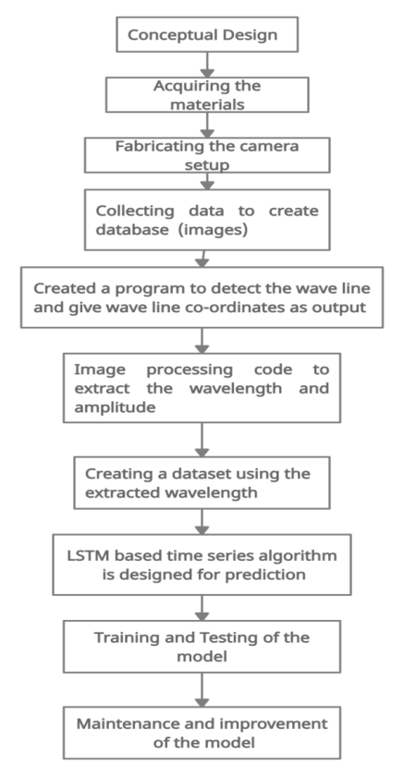

Fig. 3.1 Flow chart of the proce**ss**

**3.1 CONCEPTUAL DESIGN**

**3.1.1 Isometric view** **of camera setup**

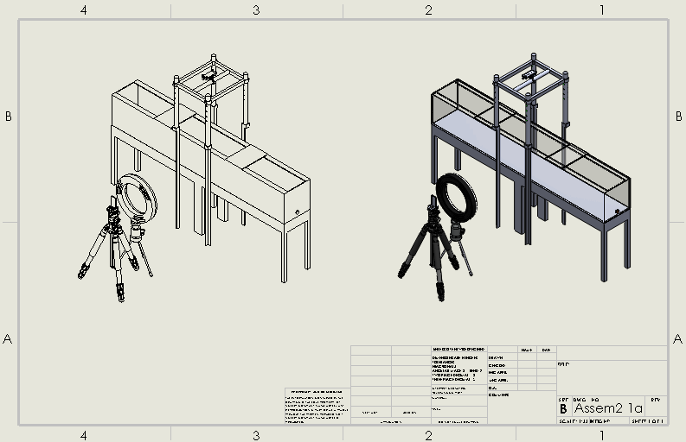

Fig. 3.2 Isometric view of camera setup

**3.1.2 Block diagram of the ML model**

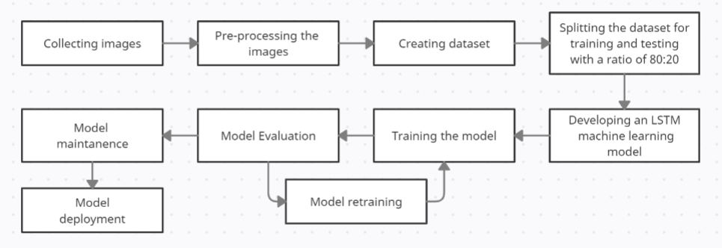

Fig. 3.3 Block diagram of the ML model

**3.2 MATERIAL SPECIFICATIONS**

Table 1: Material specification

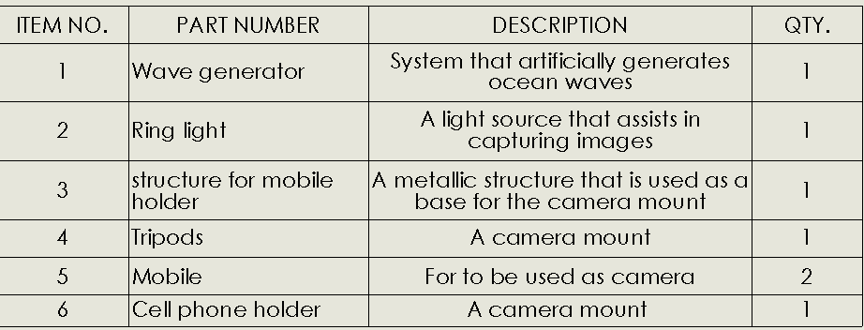

* Wave generator is a device which generates ocean waves artificially. This system uses a pulley mechanism to move the plunger in to and fro motion because of the motion the water is rammed by the plunger in such a way that waves are created in generator tank.
* Ring light is a light source that assists in capturing images for the dataset.
* Structure that holds the mobile in such a way that vertical images of the waves can be captured.
* Tripod is used to hold the mobile in such a way that horizontal images of the waves can be captured.
* Mobile phone is used as a camera to capture the images of the waves
* Cell phone holder is used in the structure to hold the mobile phone.

**3.3 CAMERA SETUP**

Camera setup was fabricated around the wave generator to capture the video of the waves which was generated by the wave generator. The captured video was then processed according to the model requirement.

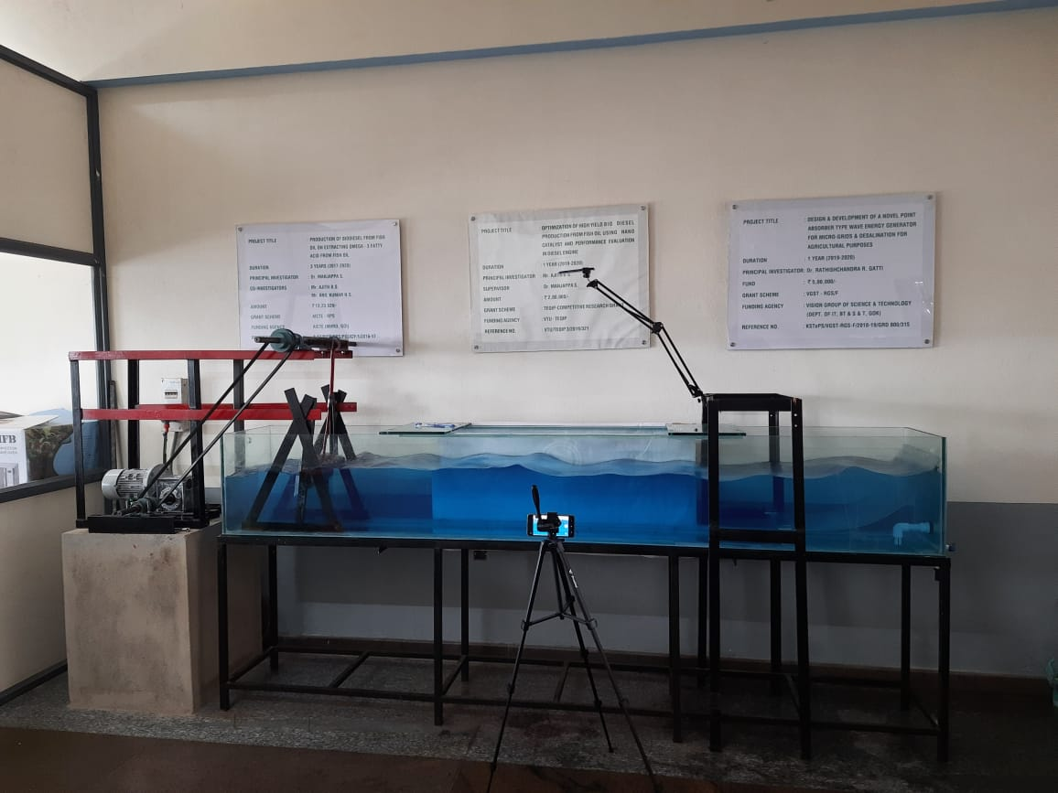

Fig 3.4 Camera setup

**3.4 PRE-PROCESSING**

The objective of the preprocessing was to obtain the wavelength and amplitude from the images for the dataset. An image processing code was developed for this purpose. This code takes the image as input converts it into gray scale and processes it to get a clear wave line of the wave then the code detects the wave line and extracts the coordinate values of the crest and trough, using this wavelength and amplitude are calculated. From the obtained wavelength the dataset for the model is created. Detailed information of the pre-processing is as follows:

* Three sets of images where taken for both side and top view of the waves.
* We used only the side view for our project.
* Side view image:

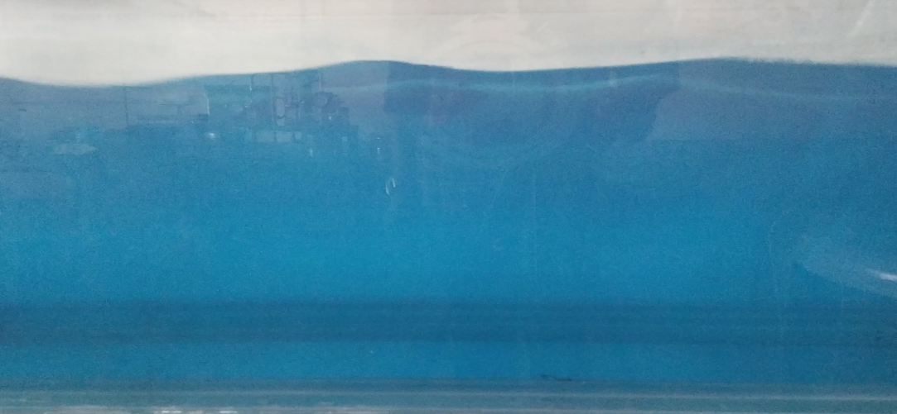

Fig 3.5 Side view

* Camera distance while taking the image from the machine for side view is 61cm
* Image height and width in real time is height = 46cm and width = 65cm
* Water level in the tank = 31cm
* Each set of the data contains a variety of wave lengths.
* Splitting the images in the ratio of 8:2 or 80% and 20%, in which 80% is for training data and 20% for testing data.
* Initially we took videos then we broke it down to images frame by frame using a python code.
* For each set of images the length of the video was 18min with a frame rate of 25 frames per sec.
* The data have been already broken into batches and for testing and training in the Google drive link <https://drive.google.com/drive/folders/17I1RpBwVcYgif9WM0LK7HONsr4IhHHZ6?usp=sharing>
* The data was broken into batches according to 1x+2x+3x=6x=27000

Where 27000 is the total number of images in each set of data.

1st batch= 1*4500= 4500 images

2nd batch= 2*4500= 9000 images

3rd batch= 3*4500= 13500 images

Below table provides the structure of the raw data.

Table 2: Raw dataset structure

|  |  |  |  |
| --- | --- | --- | --- |
| **Trial** | **Batch** | **For training data (images)** | **For test data (images)** |
| Trial 1 | Batch 1 | 3600 | 900 |
|  | Batch 2 | 7200 | 1800 |
|  | Batch 3 | 10800 | 2700 |
| Trial 2 | Batch 1 | 3600 | 900 |
|  | Batch 2 | 7200 | 1800 |
|  | Batch 3 | 10800 | 2700 |
| Trial 3 | Batch 1 | 3600 | 900 |
|  | Batch 2 | 7200 | 1800 |
|  | Batch 3 | 10800 | 2700 |

* An image processing code was developed for processing the images. This code takes the image as input converts it into gray scale then to blurred format so that all the unwanted lines are erased then to sketch format to obtain only the wave line.

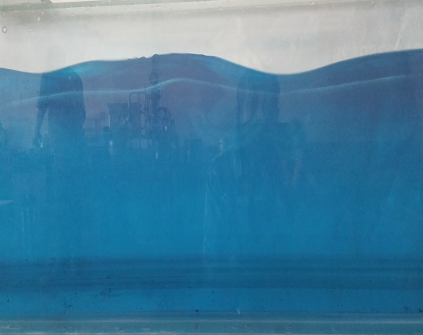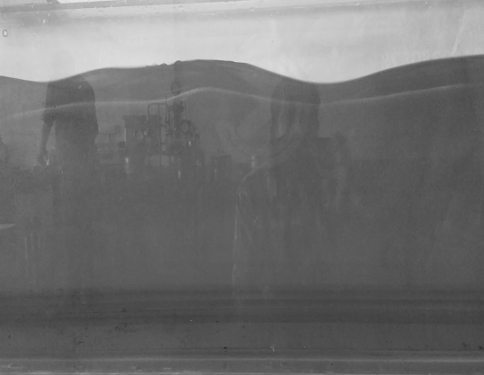 Image of the wave Gray Scale image

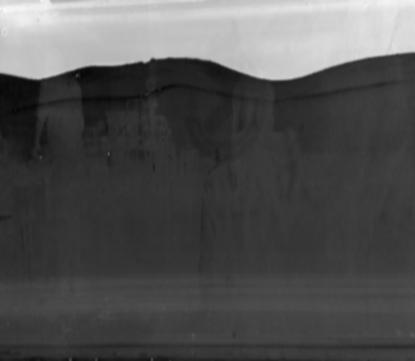

Wave line Blurred image

Fig 3.6 Processing of the image to obtain the waveline

* The image processing code then detects the wave line and extracts the coordinate values of the crest and trough.

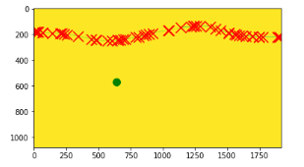

Fig 3.7 Image processing code detecting the wave line

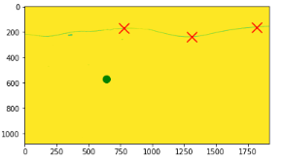

Fig 3.8 Image processing code detecting crest and trough

* Using the crest and trough the wavelength and amplitude is calculated.

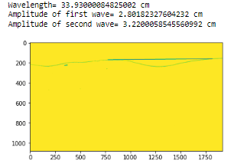

Fig 3.9 Image processing code calculating and providing the wavelength and amplitude as output

* From the obtained wavelength the dataset for the model is created.

**3.5 DATASET**

The dataset for the machine learning model was created by using the images of the ocean waves which was captured using a camera setup around the ocean wave generator. Ocean wave generator is a mechanical device that generates water waves using a plunger. The images that were captured are the pre-processed using image processing to obtain the coordinates of the wave line of the waves, from this coordinates the wavelength and amplitude were extracted. The image processing code runs in a loop taking images one by one as input, once the wavelength is calculated the wavelength is then append to a .csv file. This file is then used as the dataset for the LSTM based time series ANN model.

**3.6 MACHINE LEARNING MODEL**

A LSTM based time series prediction algorithm was used for the model. Long short-term memory is referred to as LSTM. Recurrent neural networks (RNN) that learn to predict the future from sequences of different durations employ LSTM cells. Recurrent neural networks, unlike ARIMA and Prophet, are not limited to time series and may be used with any form of sequential data. LSTM networks are RNN extensions that increase memory capacity. LSTMs are used to construct the layers of an RNN. LSTMs assign "weights" to data, which allows RNNs to either let new information in, forget information, or give it enough importance to affect the output. A recurrent neural network (RNN) is a type of artificial neural network which uses sequential data or time series data.

This model uses the dataset which contains a list of wavelength as data for training purposes, once trained the algorithm can forecast the upcoming ten wavelengths when inputted with a test dataset.

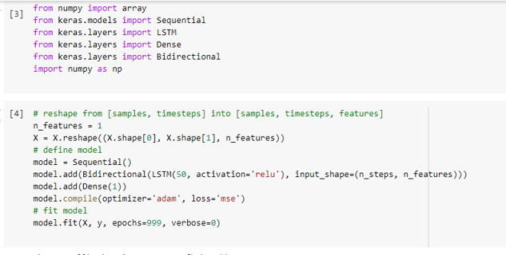

Fig 3.10 LSTM based time series ANN model

**3.7 TESTING**

* The LSTM based time series ANN machine learning model was trained using the training data. The training data contained 10000 values, due to lack of proper system and time for this test only dataset of value 10000 was used.
* A testing dataset was prepared with values around 2700.
* After the training of the model the model was executed to forecast upcoming values.
* The model forecasted values and the values in the test data were compared, to check weather successful forecasting was done.
* The model successfully forecasted the upcoming values with an accuracy of 80%.
* This model can forecast n number of wavelength values but the accuracy of the values will keep on decreasing as the number of forecasted values is increasing.
* The accuracy problem can be resolved by just training the model with larger datasets.
* The below plot represents the loss. After training the model with the dataset of 10000 values the loss is around 20%. This can be further reduced by increasing the dataset.

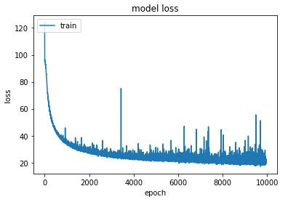

Fig 3.12 Model loss

* The below plot has two values the blue line is the test dataset values and orange line is the predicted values of the model.

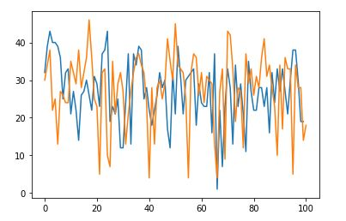

Fig 3.13 Testing result for 100 predictions

**CHAPTER 4**

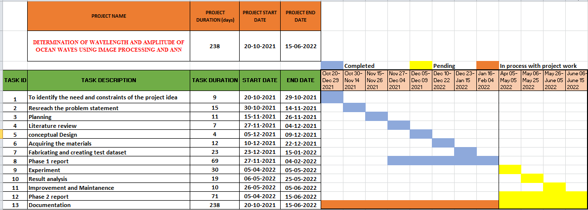**PROJECT GANTT CHART**

Fig. 4.1 Project Gantt chart

**CHAPTER 5**

**BUDGET**

Table 2: Project cost analysis

|  |  |  |  |  |
| --- | --- | --- | --- | --- |
| ITEM NO. | PART NUMBER | DESCRIPTION | QTY. | Price in ₹ |
| 1 | Wave generator | System that artificially generates  ocean waves | 1 | 0 |
| 2 | Ring light | A light source that assists in  capturing images | 1 | 400 |
| 3 | structure for mobile  holder | A metallic structure that is used as a  base for the camera mount | 1 | 1000 |
| 4 | Tripods | A camera mount | 1 | 400 |
| 5 | Mobile | For to be used as camera(Personal mobiles will be used) | 2 | 0 |
| 6 | Cell phone holder | A camera mount | 1 | 300 |
|  |  | Total |  | 2100 |
|  |  |  |  |  |

**CHAPTER 6**

**RESULT AND DISCUSSION**

* Generated datasets using the fabricated camera setup around the wave generator for testing and training of the ML model.
* Developed an image processing algorithm and code to detect wave lines and extract the wavelength and amplitude from the set of images.
* Developed a LSTM based time series prediction algorithm to successfully train and test the image and predict the wavelength.

The LSTM model that was developed was able to forecast the wavelength of the ocean waves. The model can predict up to ten wavelengths more than that will reduce its accuracy, but this can be countered by training the model with a large dataset to increase the accuracy.

**CHAPTER 7**

**CONCLUSION**

The LSTM model that was developed was able to forecast the wavelength of the ocean waves. The model can forecast n number of wavelength values but the accuracy of the values will keep on decreasing as the number of forecasted values is increasing, but this can be countered by training the model with a larger dataset to increase the accuracy.

**CHAPTER 7**

**SCOPE FOR FUTURE WORK**

* Upgrading the pre-processing method so that it can processes complex images and create the dataset.
* Further increasing the size of dataset for training and testing of the model.
* Improving the model so that it can be implemented in real-time applications of satellite top view images for oceanographic surveys.

NIOS can use the same for oceanographic surveying, surveillance, and structural integrity prediction of port structures.

**REFERENCES:**

[1] C. E. Stringari, D. L. Harris, and H. E. Power, “A novel machine learning algorithm for tracking remotely sensed waves in the surf zone,” *Coast. Eng.*, vol. 147, pp. 149–158, May 2019, doi: 10.1016/j.coastaleng.2019.02.002.

[2] M. Romano *et al.*, “Artificial neural network for tsunami forecasting,” *J. Asian Earth Sci.*, vol. 36, no. 1, pp. 29–37, 2009, doi: https://doi.org/10.1016/j.jseaes.2008.11.003.

[3] P. A. E. M. Janssen, “Progress in ocean wave forecasting,” *J. Comput. Phys.*, vol. 227, no. 7, pp. 3572–3594, 2008, doi: https://doi.org/10.1016/j.jcp.2007.04.029.

[4] H. Choi *et al.*, “Real-time significant wave height estimation from raw ocean images based on 2D and 3D deep neural networks,” *Ocean Eng.*, vol. 201, p. 107129, 2020, doi: https://doi.org/10.1016/j.oceaneng.2020.107129.

[5] S. van Cranenburgh, S. Wang, A. Vij, F. Pereira, and J. Walker, “Choice modelling in the age of machine learning - Discussion paper,” *J. Choice Model.*, p. 100340, 2021, doi: https://doi.org/10.1016/j.jocm.2021.100340.

[6] S. Agatonovic-Kustrin and R. Beresford, “Basic concepts of artificial neural network (ANN) modeling and its application in pharmaceutical research,” *J. Pharm. Biomed. Anal.*, vol. 22, no. 5, pp. 717–727, 2000, doi: https://doi.org/10.1016/S0731-7085(99)00272-1.

[7] D. Smilkov *et al.*, “Tensorflow. js: Machine learning for the web and beyond,” *arXiv Prepr. arXiv1901.05350*, 2019, Accessed: Dec. 18, 2021. [Online]. Available: https://arxiv.org/abs/1901.05350.

[8] M. Šapina, “A Comparison of Artificial Neural Networks and Ordinary Kriging depth maps of the Lower and Upper Pannonian stage border in the Bjelovar Subdepression, Northern Croatia,” *Rud. Geol. Naft. Zb.*, vol. 31, pp. 75–86, Sep. 2016, doi: 10.17794/rgn.2016.3.6.

[9] G. Xie and W. Lu, “Image edge detection based on opencv,” *Int. J. Electron. Electr. Eng.*, vol. 1, no. 2, pp. 104–106, 2013.

[10] R. Phadnis, J. Mishra, and S. Bendale, “Objects Talk - Object Detection and Pattern Tracking Using TensorFlow,” *2018 Second Int. Conf. Inven. Commun. Comput. Technol.*, pp. 1216–1219, 2018, doi: 10.1109/ICICCT.2018.8473331.

[11] W. Duan, X. Ma, L. Huang, Y. Liu, and S. Duan, “Phase-resolved wave prediction model for long-crest waves based on machine learning,” *Comput. Methods Appl. Mech. Eng.*, vol. 372, p. 113350, 2020, doi: https://doi.org/10.1016/j.cma.2020.113350.

[12] A. Lay‐Ekuakille *et al.*, “Image sensors for wave monitoring in shore protection: Characterization through a machine learning algorithm,” *Sensors*, vol. 21, no. 12, Jun. 2021, doi: 10.3390/s21124203.

[13] S. C. James, Y. Zhang, and F. O’Donncha, “A machine learning framework to forecast wave conditions,” *Coast. Eng.*, vol. 137, pp. 1–10, 2018, doi: https://doi.org/10.1016/j.coastaleng.2018.03.004.

[14] Y. Z. Law, H. Santo, K. Y. Lim, and E. S. Chan, “Deterministic wave prediction for unidirectional sea-states in real-time using Artificial Neural Network,” *Ocean Eng.*, vol. 195, p. 106722, 2020, doi: https://doi.org/10.1016/j.oceaneng.2019.106722.

**PHOTO GALLERY**

Side View

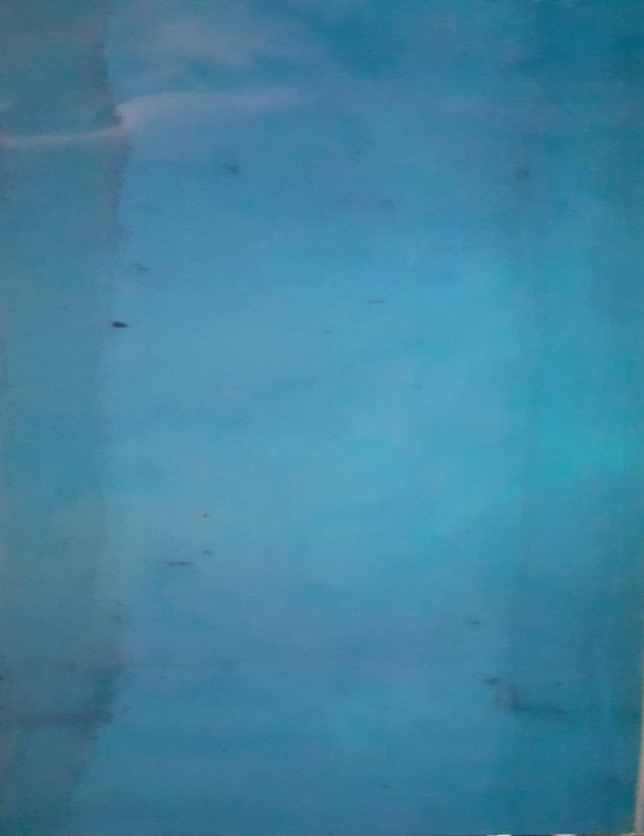

Top view

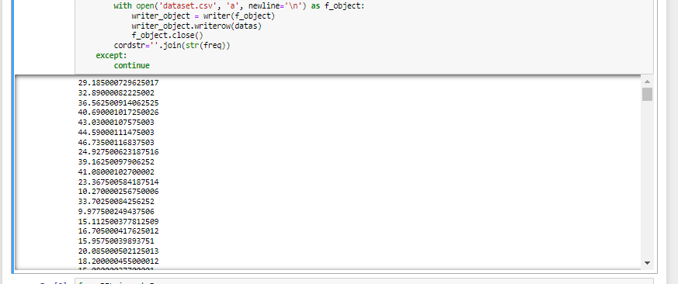

Glimpse of the process of creation of dataset

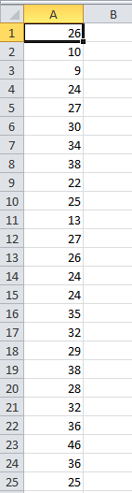

Glimpse of the dataset